Mode-Locked Femtosecond Titanium:Sapphire Laser
Version Trestles-20

TABLE OF CONTENTS

- Introduction
- Laser safety
- Laser description
- List of accessories
- Installation
- Alignment
- Day-to-day operation
- Possible problems
1. INTRODUCTION
Ti:sapphire

Titanium-doped sapphire (Ti:sapphire) is a solid state laser medium capable of tunable laser operation over broad range of near infrared (IR) wave lengths. Because of its broad absorption band in blue and green, energy for lasing process can be supplied by standard continuous wave (CW) argon ion laser or CW 532 nm, high-power, diode-pumped solid state laser as opposed to an electrical discharge or flash lamp that supplies broad band excitation.

With properly chosen optics, the Ti:sapphire laser delivers a range of wave lengths from 690 nm to 1080 nm, and pulse durations < 20 fs.

Solid-state mode-locked lasers produce femtosecond light pulses using Kerr lens mode-locking (KLM) principle of operation and continuous wave pumping sources. KLM principle combines self-focusing nonlinear optical effect and aperture effect together to reach the shortest optical pulses. This Kerr self-focusing effect leads to slight changes in the spatial intensity profile of the resonator mode in laser oscillators. As a consequence, by introducing an intracavity aperture, a power-dependent loss can be created. Owing to the quasi-instantaneous response of nonresonant Kerr nonlinearities, the amplitude modulation induced by self-focusing is able to simulate ultrafast saturable-absorber action and support pulse formation down to the femtosecond regime in solid-state lasers that have long gain-relaxation times. The gain bandwidth of solid state laser materials such as Ti:sapphire extends over >200nm and has the potential for supporting pulses of less than 10fs. The pulse duration from these lasers is determined by critical interplay between intracavity self-phase modulation in media, and negative group delay dispersion.

Trestles-20 femtosecond laser head contains the Ti:sapphire rod and the optics that form the resonator cavity.

DEL MAR PHOTONICS guarantees that provided laser was tested and it is suitable for the Kerr lens mode-locked operation. On the one hand, the laser installation without the help of the manufacturer requires some experience of the user in laser physics. But on the other hand, by working with our laser you will gain experience in ultrafast laser technology.
2. LASER SAFETY
Trestles-20 and its pump laser are Class IV –high-power lasers, whose beams are, by definition, safety and fire hazards. Take precautions to prevent exposure to direct and reflected beams. Diffuse as well as secular reflections cause severe skin or eye damage.

Trestles-20 laser emits CW and pulsed infrared radiation; it is extremely dangerous to the eye. Infrared radiation passes easily through the cornea, which focuses it on the retina, where it can cause instantaneous permanent damage.

Safety Precautions

- Wear protective eyewear at all times; selection depends on the wavelength and intensity of the radiation, the conditions of use, and the visual function required. Protective eyewear vendors are listed in the Laser Focus World, Laser Optronics, and Photonics Spectra buyer’s guides. Please use safety instructions of your pump laser and follow their recommendations in your work.
- Maintain a high ambient light level in the laser operation area. This keeps the pupil constricted, thus reducing the possibility of eye damage
- Keep the protective cover on the laser at all times.
- Avoid looking at the output beam; even diffuse reflections are hazardous. Keep all beams below eye level always. Never look in the plane of propagation of the beams.
- Avoid wearing jewelry or other objects that may reflect or scatter the beam while using the laser.
- Use an infrared detector or energy detector to verify that the laser beam is off before working in front of the laser.
- Operate the laser at lowest beam intensity possible, given the requirements of the application.
- Expand the beam whenever possible to reduce beam power density.
- Avoid blocking the output beams or its reflection with any part of the body.
- Establish a controlled access area for laser operation. Limit to those trained in the principles of laser safety.
- Post prominent warning signs near the laser operation area (Fig.1).

DANGER
VISIBLE AND /OR INVISIBLE LASER RADIATION
AVOID EYE OR SKIN EXPOSURE TO DIRECT
OR SCATTERED RADIATION
CLASS IV LASER PRODUCT
Fig.1. Standard safety warning sign

- Provide enclosures for beam paths whenever possible.
- Set up shields for secular reflections.
- Set up an energy absorbing target to capture the laser beam, preventing unnecessary reflections or scattering.

Be very careful while executing any step of the alignment. Avoid any exposure to the direct and reflected laser beams. Direct and reflected laser radiation from pump laser and Ti:sapphire laser can cause serious eye damage. Remember that Ti:sapphire radiation is invisible or looks like red laser radiation of low intensity. However, it is dangerous even at lowest intensity. Intense incoherent luminescence is emitted from the Ti:sapphire rod also.

We recommend using protective boxes covering all elements outside of the Ti:sapphire laser.

Follow the instructions listed in this manual for safe operation of your laser.
3. Laser description
General overview

The Trestles-20 laser head contains the Ti:sapphire rod and optics that form the oscillator cavity. Elements include pump beam mirrors, laser rod, focusing lens and mirrors, an output coupler (OC), high reflector (HR), beam folding mirrors, prisms as dispersion control elements and slit as spectral turning element.

Connections to the laser include cooling water, power and control from “Electronics Module” and power and slit driver module (optional).

Option:
The Electronics module enclosed with the laser consists of the pulse detection circuit and driver circuits for electromechanical starter. All indicators and controls are located on the front and upper panel. One cable connects it to laser head, the other pump cable and BNC cable may be connected to customer’s oscilloscope.
Slit driver module enclosed with the laser consists of circuits for moving slit in side the laser head.

Pumping optimization

For continuous-wave (CW) pumping, there is one basic requirement for lasing action: the unsaturated round-trip CW gain must exceed the round trip loss from all sources. The CW gain is obtained by having a high inversion density and an adequate length of Ti:sapphire material. The high inversion density comes from having a high pump intensity and high Ti3+ ion concentration. Losses in the Ti:sapphire laser come from losses in mirror coatings and polished surfaces, and what is more important, the residual loss in the Ti:sapphire material itself. This loss is proportional to the rod length and varies with the Ti³⁺ concentration, generally increasing as the Ti³⁺ concentration increases.

Unlike a dye laser, the pump illumination in Ti:sapphire laser must be collinear with the cavity mode over a relatively long length of laser rod. Continuous, high inversion density over the entire volume of a rod several millimeters in diameter is difficult to achieve. To circumvent this problem, the pump light is focused to a narrow line within the rod and the oscillating laser mode is similarly focused and overlapped within the same volume – a technique known as longitudinal pumping. The output beam is then collimated and expanded to normal size. The residual pump beam is dumped through the second cavity focus mirror.

Trestles-20 laser description

Pump laser

Because of its broad absorption band in blue and green, energy for lasing process can be supplied by standard continuous wave (CW) argon ion laser or CW 532 nm, high-power, diode-pumped solid state lasers. It is very important to note that pump laser should work in TEM₀₀ mode.

For pumping Trestles-20 laser a pump laser operating in TEM₀₀ transverse mode regime with output power between 3 - 5 Watts should be used. Performance values given in this manual are based on using a 4 W pump beam unless otherwise noted. When using other than a 4 W pump, the output mirror should be changed. Please remember that stable operation of pump laser is the key for reaching good femtosecond operation of Ti:sapphire laser. TEM₀₀ mode is very important.

We recommend Spectra-Physics BeamLokTM argon laser operating in power mode, Spectra-Physics Millennia i/s Series lasers, Coherent Verdi Series.

The folded cavity

DEL MAR PHOTONICS modeled, analyzed and optimized the cavity design for optimum performance in minimal space. The result was a five mirror folded cavity (Fig. 2). This scheme incorporates 5-mirror cavity (M1, M2, M3, M4, M5), Ti:sapphire crystal (TiS), lens for focusing of pump radiation (F), two prisms (P1 and P2) and slit (S).

In folded cavities where astigmatism is not eliminated, output beams are elliptical and hard to focus. But by carefully choosing the angles of the cavity focus mirrors and rod length, astigmatism in Trestles-20 output beam is virtually eliminated.

Wavelength turning characteristics

Because the Ti:sapphire rod is birefringent, uninterrupted tuning is achieved when the c – axis of the rods is aligned coplanar with the polarization of the electric field within the cavity. Since the Ti:sapphire rod and prism surfaces represent a total of six Brewster's angle surfaces, the polarization within the cavity is largely determined by the orientation of these surfaces. Furthermore, cavity losses are minimized and tuning is optimized when all these surfaces are accurately aligned at Brewster's angle. The Trestles-20 laser uses a proprietary Ti:sapphire rod holder that orients the rod surfaces at Brewster's angle and allows the c axis of the rod to be aligned coplanar to the electric field vector. This technique compensates for unavoidable errors in rod orientation that occur when the rod is cut and polished. Wavelength tuning range of the Trestles-20 laser is 740 nm to 950 nm with two sets of optics (i.e. the rod and system are capable of continuous turning over this range).

The Trestles-20 laser comes with the optics set(s) you specified when you ordered your laser. It is important to note, that sub 20 fs pulses are generated in 780-840 nm range with external extra-cavity dispersion compensation.

Option:
Extra-cavity prism pair for pulse compression
.

Wavelength selection

The fs Trestles-20 laser is wavelength tuned using a prism sequence and a slit. This sequence provides a region in the cavity where the wavelengths are spatially spread. A variable slit is located in this dispersed beam. The output wavelength is tuned by changing the position of the slit in the horizontal plane. The width of the slit can also be changed so that the bandwidth (and, hence, the temporal width) of the output pulse can be varied. This simple, straight-forward method covers the entire Ti:sapphire range for ultrashort pulses.

Key diagram of Trestles-20 laser.

Pulse width selection

The pulse width tuning characteristics of the Ti:sapphire laser are influenced by two factors: those inherent in the Ti: sapphire material itself and those from cavity parameters. While we cannot readily modify the Ti:sapphire material to change pulse width, we can modify the net group velocity dispersion (GVD). The optical components in the laser cavity introduce positive GVD and cause pulse spreading. Further pulse spreading causes self-Phase modulation (SPM) in the Ti:sapphire rod, which results from the interaction of the short optical pulse with the nonlinear refractive index. In order to obtain stable short output pulses, these effects must be compensated with negative GVD. Prism pairs are used to produce a net negative intracavity GVD in the femtosecond system. This allows the system to produce sub 20 fs near transform limited pulses over most of wavelength regime.

The scheme of laser depicted in the fig. 3. Laser consists of the following optical elements for the basic configuration:

1. 5 mm long Ti-doped sapphire crystal (TiS);
2. Dielectric mirrors M1, M2, M4, M5, M6, with high reflection (>99.5%).

M1, M2 - high reflector transparent for laser pumping radiation, radius of curvature is 100 mm; M4, M5, M6, M9 - high reflector, flat mirrors; M3, output coupler; M7, M8 – high reflector (Ar-ion or 532 nm laser pump), flat mirrors.

3. F - lens for focusing of pumping radiation, focal length is 80 mm.
4. P1, P2 - prisms, Brewster angle incidence at 800 nm
5. PR – is used for changing the polarization of pump beam from vertical to horizontal.
6. A1, A2, A3 – aligning apertures.
Our laser is a flexible system which allows the user to change the laser cavity at will. You can improve your laser according to recent and future achievements in the field making only minor changes of optical and mechanical components. These instructions have been written for basic optical scheme incorporating 5 -mirror cavity in z-configuration (Fig.2).

Our laser Trestles-20 contains slit (S) placed near P2 (or M4 mirror) operating as a dispersive element for wavelength tuning and stabilization.

We use mirrors M6 in the process of alignment (see alignment procedure).

Scheme of Trestles - 20 Laser
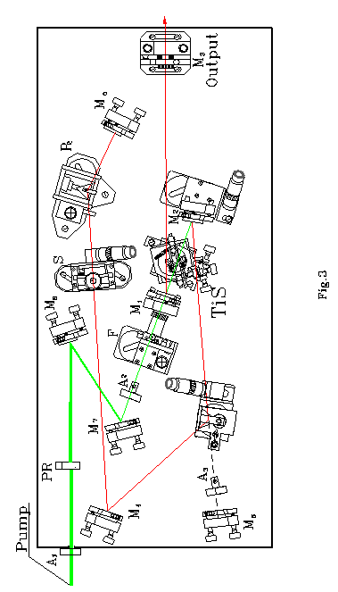
Overhead View of Trestles - 20 Laser
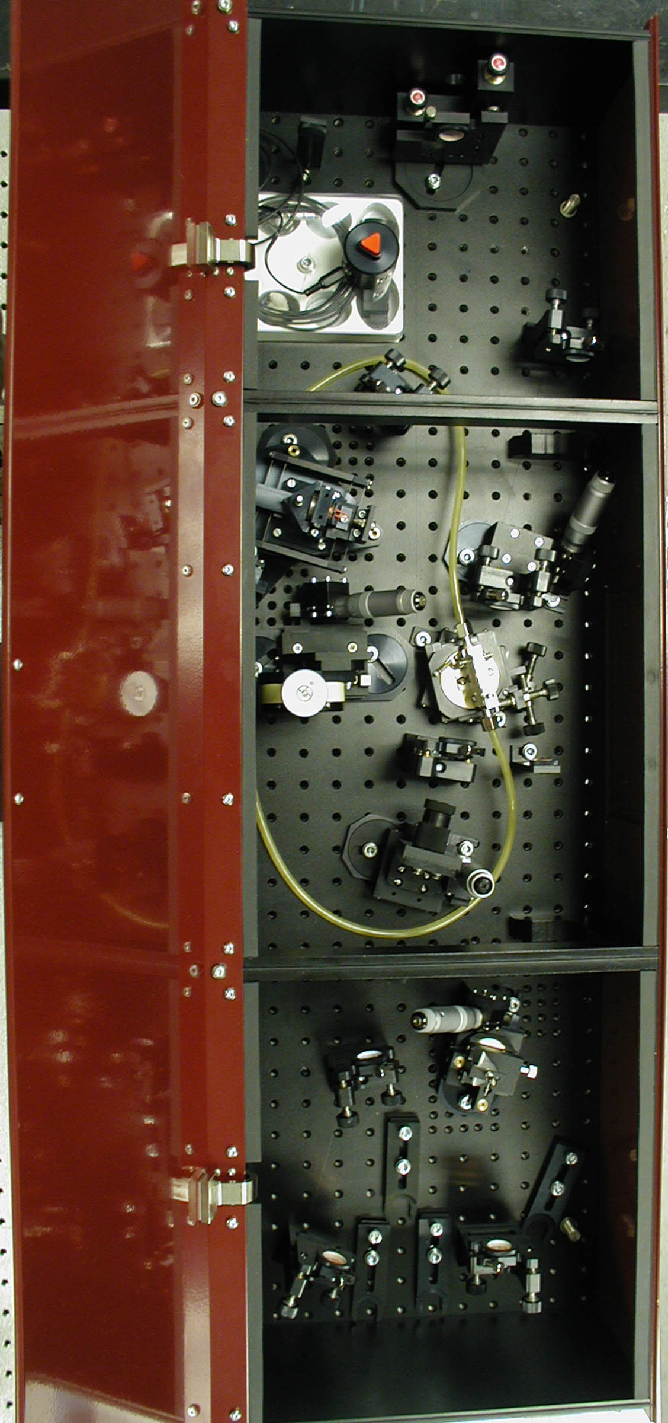

4. LIST OF ACCESSORIES
You need for assembling, testing and operation of femtosecond Ti:sapphire laser :

- A pump laser operating in TEM₀₀ transverse mode regime with output power 3 -5 Watts. Please remember, that stable operation of the pump laser is the key point for achieving good femtosecond operation of Ti:sapphire laser. TEM₀₀ mode is very important.
- Optical table. Ti:sapphire laser itself requires about 0.5 m x 1.3 m area of the optical table. We recommend placing the pump laser and Ti:sapphire laser on the same optical table for better stability.
- Pumping laser radiation should be horizontally polarized. If you have vertically polarized pump laser radiation, please use polarization rotator (PR).
- A photodiode with >10 mm2 sensitive area or low-inertial power meter for fast control of relative output power in the process of alignment.
- A power meter for control of output power value.
- If you did not order the electronics module you will need a fast photodiode with 400 MHz oscilloscope to display the temporal structure of output radiation.
- Interferometric autocorrelator for the measurement of pulse duration. Time resolution should be better than 10 fs. (We recommend using DEL MAR PHOTONICS femtosecond autocorrelator that is completely compatible with DEL MAR PHOTONICS Trestles-20 laser.)
- Spectrometer or diffractive grating operating near 800 nm for spectrum control.
- Infrared sensor card for observation of weak IR luminescence.
- For most stable operation of laser use dry nitrogen gas to remove dust and water vapor from laser head.
- We recommend using a chiller to keep the Ti:sapphire rod at a constant temperature for performance stability.
5. INSTALLATION
Unpacking your laser

Your laser was packed with great care and all containers were inspected prior to shipment: the laser left DEL MAR PHOTONICS in good condition. Upon receipt of your laser, immediately inspect the outside of the shipping containers. If there is any visible damage to the container, make sure a representative of the carrier company is present when you unpack the laser.

Carefully inspect your laser as you unpack it. If you notice any damage, such as dents, scratches or broken knobs immediately notify the carrier and your DEL MAR PHOTONICS Sales representative.

Open the cover of the laser head and remove bags covering the elements of laser and fixing elements which are used for transport. Carefully remove the bags, try not to misalign the laser, and damage mirrors during this procedure.

Placement of Trestles-20 laser head.

- Turn on the pump laser according to its instruction manual and allow it to warm up.
- Verify the output of the pump laser meets specifications for power and mode quality. (For pumping Trestles-20, the pump laser should be operating in TEM₀₀ transverse mode regime with output power of 3 - 5 Watts.)
- Reduce pump laser power to the minimum.
- Close the pump shutter.
- Place the Trestles-20 laser head on the table near the pump laser.
- Hook up the water hoses to the laser head.
- Adjust the heights of the pump laser and/or Trestles-20 laser head so the output beam of pump laser is parallel to the table top surface and at the same height as the middle of the “pump window” on the Trestles-20 laser head.
- Adjust the height of pump laser according it users manual.
- Adjust the height of Trestles-20 laser head
- Loosen the locking nut on each foot.
The nuts are threaded onto each leg and jam against the bottom of the base plate to lock the foot in place and to add stiffness to the foot.
- Wrench the foot to adjust the height so the center of input window is on the same height as the center of output window of pump laser above the table and parallel to the table top.
- Tighten the locking nuts.
- Place the Trestles-20 at a suitable “working place” on optical table.
- Secure the Trestles-20 laser head to the table with the four foot clamps provided.
The clamps slide over the lower portion of each foot.
- Verify the height adjust locking nuts on the feet are tight.
- Use external routing mirrors to route the pump beam to the Trestles-20 laser head.
- Open pump shutter.
- Adjust the external routing mirrors until the pump beam passes through the input window and passes through the apertures A1, A2 inside the Trestles-20 laser and strikes the centers of the pump mirrors M8 and M7. For this aligning procedure do not align M7 and M8 mirrors, adjust only external routings mirrors.
- Close the pump shutter.

For motorized slit option:
- Connect the slit control buttons to the laser head. Tap power supply into power line (AC 220 V / 50 Hz).

This completes the installation of Trestles-20 laser head.
6. ALIGNMENT
This part of our instructions describes installation and alignment procedure for the Ti:sapphire oscillator. Researchers use slightly different approaches to constructing a mode-locking Ti:sapphire laser (see review paper, references ). If you have good experience in laser technology, you can use your own approach to the alignment of our femtosecond laser. Nevertheless, we hope that our instructions will help you in your work. Alignment procedure consists of two stages. The first stage is an alignment of continuous wave (CW) Ti:sapphire laser. The second stage is a transformation of standard CW configuration to a configuration suitable for mode-locking operation.

Alignment of continuous wave Ti:sapphire laser

The laser was factory aligned and under careful transportation conditions you can try to achieve the lasing without full laser realignment.

- Adjust the external routing mirrors until the pump beam passes through the input window and passes through the apertures A1, A2 inside the Trestles-20 laser and strikes the centers of the pump mirrors M7 and M8 and passes through aperture A2. (for this aligning procedure do not align M7,M8 mirrors, adjust only external routings mirrors). Then blow dust from the mirrors and prisms. And try to achieve the generation (go to 23). If you do not achieve the laser generation then follow the procedure from the beginning.
- Switch on cooling water (moderate water flow >=0.5 liter/min).
- If your pump laser is working in a vertical polarization then adjust PR.
- Loosen the screw that clamps the PR mount to the tabletop.
- Place the target to block the reflected beam from the first surface of the Ti:sapphire crystal.
- Rotate the PR mount around its vertical axis at small angles and find the position where the spot on the target has minimal brightness.
- Verify that the pump beam is still passing through the center of PR.
- Tighten the screw that clamps the PR holder to the tabletop.

It is not necessary to follow the italicized instructions. You should only carry out these procedures in case of complete laser misalignment under severe transportation conditions. Please, follow the bold-typed instructions.

- Remove M1 and M2 mirrors with holders from their mounts.
- Remove focusing lens F with the draw-tube from mount

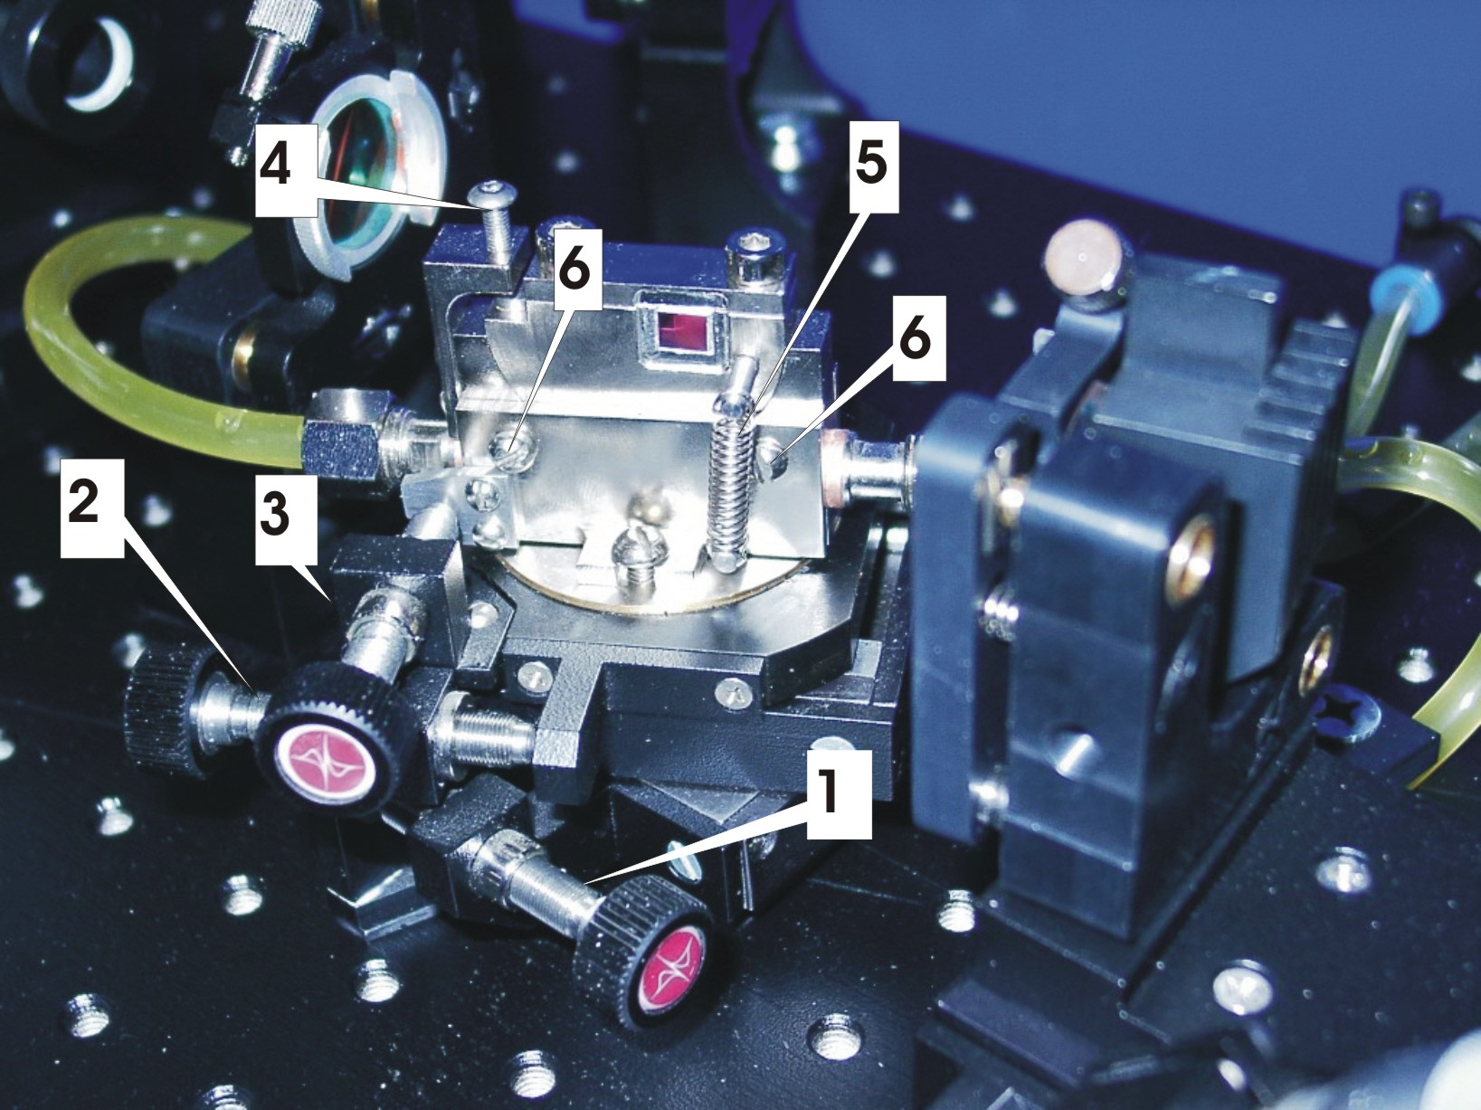
1. Screw for aligning crystal position on optical axis. 2. Screw for transverse aligning. 3. Screw for aligning Brewster angle. 4. Screw for aligning crystallographic axis orientation. 5. Spring
6. Fixing screw
Fig.4

- Remove the crystal with the crystal holder (fig. 4).
- Remove two vertical springs from the holder using a metallic hook (metallic hook may be easily made from paper clip) or thin-flat-nose pliers.
- Loose but not remove four clamping screws, two on each side of the crystal mount.
- Remove the crystal with crystal holder.
- Open pump shutter.
- Verify that the pump beam passes through the centers of A1, A4 and A2.
- Direct the pump beam with M7 and M8 mirrors through center of A2. Close pump shutter.
- Remove the A2 aperture from aperture holding stage.
- Install the focusing lens with a draw-tube back to the lens mount. Open pump shutter.
- Verify that the center of the beam spot on the box wall at the same point.
- If the centers do not coincide in vertical plane then use the vertical lens adjusting screw to align the lens. (Some laser systems have lens holders without vertical aligning screw. If so then loosen but don’t remove fixing screws. Align the position of the lens and then fix the screws.)
- If the centers do not coincide in horizontal plane then loosen the screws that clamp the lens holding stage to the table top and move the translation stage in perpendicular to pump beam direction to align the lens.
- Verify that the center of the spot is not moving while you are moving the lens forwards and backwards while holding the base of the translation stage in place with your hand. If the center of the spot is moving then rotate the stage (for example, if the center of the spot moved to the left side while the lens was moved closer to M1 then rotate the lens stage clockwise a small angle), then align the centers by moving stage perpendicular to pump beam direction to align the lens. Repeat this step until the center of the spot will not move and will coincide with center of A3 during lens translations along pump beam. Tighten the clamping screw.
- Close the pump beam shutter.
- Install the M1 mirror with the holder to its mount.
- Install M2 mirror with the holder to its mount. Set up the distance between M1 and M2 surfaces to approximately 106 mm.
- Open the pump beam shutter.
- Place a beam stopper beyond M2 mirror.
- Open the shutter. Using insertion adjusting screw of the P1 prism, remove the prism from the beam path. Aligning M2 mirror, direct the pump beam to the center of the M6 mirror.
- To align M6 mirror direct pump beam back to the center of M2 mirror. Increase pump power up to 3-5 W. Use protective goggles for pump laser radiation.
- Aligning and positioning of the lens. Use protective goggles for pump laser radiation during this procedure. Remove beam blocker, beyond mirror M2. Translating the lens find the position when round shape of the pump beam will abruptly change to the oval shape. Replace the beam blocker.
- Use IR card to see the luminescence near M3 mirror.

+ reflection of M2-M6-M2-M1-M3

reflection of M1, M3 only

- Aligning M1 mirror, direct luminescence reflected only from the M1 to the center of the M4 mirror.
- Aligning M3 mirro, direct luminescence reflected only from the M1, M3 mirrors to the center of M6.
- Position of (+) spot is adjusted by M9 controls. The spot should be approximately on the center of spot reflected from M1, M3 only.
- Align M6 mirror so the reflected beam returns back to the center of M3.
- If a correct alignment has been done, laser radiation should appear after small adjustments of M3 and M6. If not then place the additional photodiode with large aperture beyond the M3 mirror. The luminescence spot should be in the active area of photodiode. Adjust M3, M6 and position of M2 mirrors for a maximum signal until generation will appear. Remove the photodiode.
- Place the power meter in the beam.
- Adjust M6 and M3 mirrors for maximum output power. For optimization of Ti:sapphire output power adjust M3 and M6 by horizontal controls together and vertical controls together also. Output power should be close to the maximum when the spots on M1 look like picture depicted below:

green red
Pump laser and Ti:sapphire generation on mirror M1

- By small steps move M2 along the optical axis, try to find maximum output power. Make additional small adjustments using M3 and M6 controls after each step.
- Move Ti:sapphire crystal along the optical axis, try to find maximum output power. Make additional small adjustments using M3 and M6 controls after each step.
- Adjust Brewster angle using Ti:sapphire crystal angle control in small steps. Try to reach maximum output power. Make additional horizontal adjustments using M3 and M6 controls after each step.
- Adjust focusing lens position and Ti:sapphire crystal along the optical axis in small steps. Try to reach maximum output power. Make additional small adjustments using M3 and M6 controls after each step.
- Verify that Ti:sapphire output power is not less than 10% - 15% of pumping power. If not, repeat steps 33-38. Sometimes, you should repeat steps 33-38 several times during the first alignment of the CW Ti:sapphire laser. It requires patience. And it may be necessary to clean the mirrors and crystal surface.
- Write down maximum output power and position of M2 micrometric screw. Move M2 forward and back and find positions of micrometric screw where Ti:sapphire laser oscillation disappears. Write down these positions. This is the range of stability.

Note. There are two ranges of stability in the asymmetric cavity (see G.Cerulla et. al., Opt.Lett. 19 (1994) 807).

Alignment of mode-locked Ti:sapphire laser.

- Flip the slit aside.
- Using adjusting screw of the P1 prism insert prism into the beam path. Moving the prism you can find the position of prism, when laser oscillation begins between mirrors M3 – M6 and small fraction of this generation is deviated by P1 prism.
- Verify the correct aligning of the prism
- Loosen but don’t remove the rotation fixation screw R (fig. 5).
- Rotating the prism’s base plate adjust prism for minimal deviation of the beam.
- The heights should be also 70 mm above the laser head table top. If it is necessary use the adjusting screws to align the prism (see the figure on the next page).(continued on the next page)

1, Prism
2, fixating screw
3, screw V
4, screw H
5, screw R
6, base plate

Fig.5. Schematic picture of prisms fixation and service.

1 - fused silica prism
2 - fixating screw, ! DO NOT OVER TIGHTEN : to much force will cause birefringence in glass of prism !
3 - screw V to align deviated beam in vertical plane,
4 - screw H to align reflected beams in vertical plane,
5 - screw R to fix rotation of base plate 6,
6 - prism's base plate rotating by hand.

- Verify that beam strikes P2 prism. Verify the height of the beam near P2.
- Using adjusting screw of the P2 prism insert prism in the beam path. Verify correct alignment of the prism in same manner as in steps 33-37.

Note: If your laser was provided with a electro-mechanical starter, then P2 holder mounting is replaced by electro-mechanical starter. Align the minimal deviation angle by the same procedure but loosen the fixing screws clamping stage to the laser head table top and rotate whole stage.

- Align M5 to return deviated by P2 prism part of beam back.
- Insert P1 prism into the beam, by small adjustments of M5 mirror direct the laser generation through the prisms. Block M6 mirror by blocker (aperture A3).
- Aligning M5 and M3 to find maximum output power in same manner as described in steps 33 -37 (CW operation).
- Verify that output power is only 15-20 percent lower then output power without prisms. If not, repeat step 42. Sometimes, you should repeat steps 33-38 several times during the first alignment of the CW Ti:sapphire laser. It requires patience.

Note: After finishing this procedures there are some check points:

- The spot on the M1 mirror should be look like that described instep 28. If not align M3 and M5.
- There are beams reflected from the apex of each prism. The beams should be almost parallel to each and must be in resonator plane (plane at 70 mm above table top of the laser head). If not then align the prisms and M3, M5 to fix it.
- Align P1 so that laser generation is passing almost through the apex of prism. But generation should not be lost.
- Test the output beam using fast photodiode and oscilloscope.
- Using the position aligning screw remove P2 from the pump beam. The laser generation will be lost.
- Moving the P2 prism with your finger (thus you change the depth of insertion of the prism) look at the result on the oscilloscope. Then moving M2 by small steps find the position where the pulses appear. Femtosecond pulses should appear near the end of the region of stability. Continuous pulse train should be observed on the oscilloscope screen in femtosecond operation.

Note: We remind you that two regions of stability exist in asymmetric cavity. You are moving through the stability region having less distance between M1 and M2.

- Manage to achieve the situation when pulses train is observed while you hold the prism in place. Then align the prism position screw to hold the prism in place.
- The laser was aligned at pump power 3W and output coupler 5% transmission. For higher pump level use output couplers with higher transmission (options).
- Measure the spectrum of Ti:sapphire laser radiation with help of spectrometer or diffractive grating.
- 51. Measure the spectrum and try to find its optimum using control of P2 mount. You will obtain shorter pulses with broader spectrum. Spectral bandwidth should be not less than 40 nm at FWHM (full width half maximum). It corresponds to 20 fs (sech2).
- Femtosecond operation is started by moving of optical elements. Once started, femtosecond operation lasts in hours at good pump laser stability and in stable room conditions. When femtosecond operation disappears, start it again with mechanical movement of P2.
- Measure pulse duration with autocorrelator.
- To adjust output wavelength and to control spectral bandwidth, flip back the slit. While inserting the P2 prism, you will see that the spectrum is not only broadening but the center wavelength is moving to the “blue” part of the spectrum, and sometimes a non pulse radiation occurs in the “red ” part of the spectrum. Align the slit to “cut off” the non-resonant part of the spectrum and align the central wave length. Sometimes it is easy to tune the laser by the P2 insertion and use slit for small corrections and “cut off” of the unwanted part of spectrum.
7. DAY-TO-DAY OPERATION
1. Switch on cooling water for Ti:sapphire laser (moderate flow).
2. Switch on the pump laser (3-5 W output).
3. Ti:sapphire will give proper characteristics after 30 minutes if you use standard pump laser or after 20 min. with "Beam-Lock" Ar-ion lasers. Pump power should be stable from day to day.
4. Small adjustments of M3 and M5 might be necessary in day-to-day operation
5. To turn off the system repeat the procedure in reverse order.

Note: Occasionally, it may be necessary to clean the optics and surfaces of the Ti:sapphire crystal. The best method for cleaning surfaces is to first block the pump laser beam and then blow excess particles from the surface. Then fold a piece of lens tissue into a pad and clamp with a hemostat (usually provided with the pump laser). Soak this pad with spectroscopic grade acetone or methanol, and shake off the excess liquid. Then make one cleaning stroke only across the surface (particles on the surface can become imbedded in the tissue and act as an abrasive if a second stroke is made across the surface).
8. POSSIBLE PROBLEMS
1. Pump laser output is not TEMoo mode
2. Pump laser is not stable enough
3. Optical surfaces of laser elements are dirty.
4. Alignment steps where not performed correctly to reach good femtosecond pulses. Repeat alignment.

Mode-locked laser starter LS-214
User manual

Starter LS-214 is intended for continuous monitoring of optical signal of mode-locked lasers and disturbing resonator on case of mode-locking mode break .

Starter consists of avalanche photodiode (See fig. 1) powered from linear adjustable regulator, resonant amplifier, detector, watch-dog timer, one-short pulse generator and output driver. Detector output is proportional to first harmonic component amplitude of input optical signal. Central frequency of bandpass filter could be adjusted in a range of 80 ..120 MHz. If detector output is lower then threshold value for a period longer then 0,5 sec, single output pulse will be generated.

Pulse amplitude and, consequently, resonator disturbance degree could be adjusted to provide a reliable and smooth mode-locking start-up. Output driver provides electrical pulse output for electromagnetic actuator. RF service output (BNC female connector, 50 Ohm) could be used for monitoring of a photodiode output.

Fig. 1

Device controls and connections are shown at Fig. 2.

6
5
4
3
2

1

Light
14

13
12
11
10

9

8
7

Fig. 2
- “AMPLITUDE” – adjust amplitude of prism vibration.
- “ON / OFF” - pulse enable switch. When off, no output pulse will be produced regardless of input signal level.
- “BUZ” - Beeper enable switch. Enables sound signal (short beeps) during absence of optical pulse train.
- “CONT” - green LED . Indicates actuator driver output enabled.
- “ALARM” - Red LED. Indicates an absence of input pulse train.
- “LEVEL” - Amplifier sensitivity adjust. Rotate clockwise to increase sensitivity.
- “HIGH” – Red LED. Indicates overloading by input beam intensity.
- “LOW” - Yellow LED. Indicates low level of input beam intensity.
- “NORM” – green LED. Indicates normal level of input beam intensity.
- “LAZER” - optical beam input. A light spot should be pointed at the center of photodiode substrate. Sensitive area size is about 1 x 1 mm. Adjust beam position monitoring signal by a scope.

- OUT” - 50-Ohm BNC connector. Photodiode signal output - to scope.
- “REM” - remote status connector. Output opto-isolated FET switch is on during absence of optical pulse train.
- “POWER” - Power supply connector (+15V, DC voltage)
- “ACT” - Driver output connector - to actuator.
INSTALLATION AND ALIGNMENT
1. Connect pulse prism actuator to LS-214 using driver output cord.
2. Start femtosecond operation of Ti: sapphire laser.
3. Connect LS-214 to DC power supply (+_ 15V).
4. Direct a portion of the output radiation (<=10mW) to the photodiode of LS-214. At suitable level of light green LED “Normal” (9 in Fig.2) will turn on on.
5. Connect 50-Ohm BNC connector (11 in Fig.2) of LS-214 with 400 MHz oscilloscope.
6. Amplitude of the oscilloscope signal should be about 0.1 V. Use additional lenses to focus radiation to photodiode if necessary.
7. Rotate amplifier sensitivity adjust (6 in Fig.2) clockwise until red LED (5 in Fig.2) lights off. Red LED lights on when mode-locking mode shutting down.
8. Switch on pulse enables switch (2 in Fig.2). Green LED "control" (4 in Fig.2) lights on.
9. Rotate amplitude adjust (1 in Fig.2) clockwise (i.e. maximize deviation of prism).
10. Cross beam inside the cavity for a short period. Femtosecond operation should appear in a few seconds after that.
11. By adjusting the prism deviation select best value for femtosecond start.

Attention! LS-214 controls femtosecond operation at occasional failures. It cannot start mode locking in unaligned cavity.

